Appendix A: Descriptive statistics

Table A1 shows shares of employees and firms falling in different categories of bargaining in our working sample, by country and by year, also including firms that do not apply any form of collective bargaining (i.e., contract wages separately with each single employee).

Table A1: Share of firms and employees under different bargaining regimes, by country and year

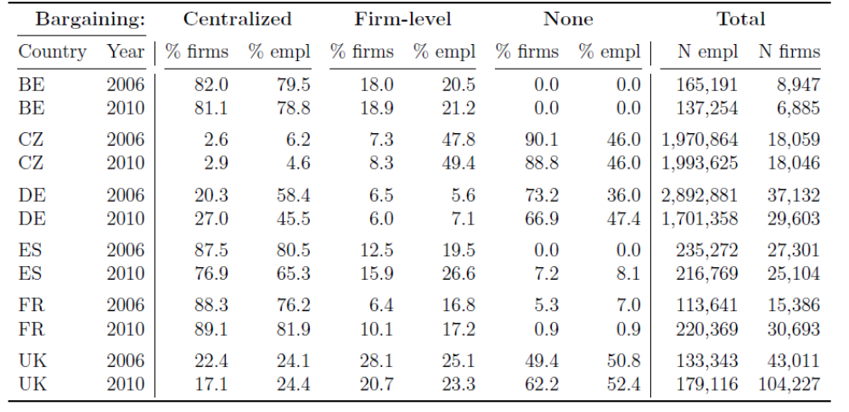

Table A2, Table A3 and Table A4 provide basic descriptive statistics for variables entering as controls in the regression analysis.
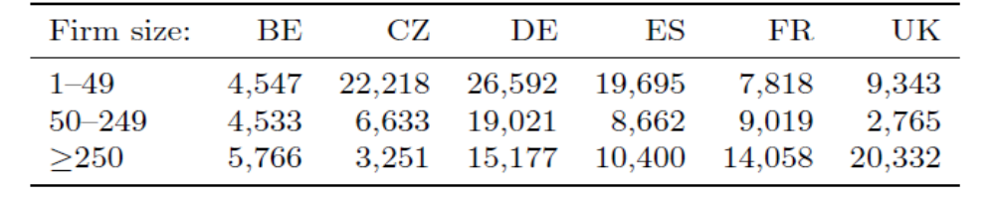

Table A3: Summary means and standard deviations for continuous variables in regression
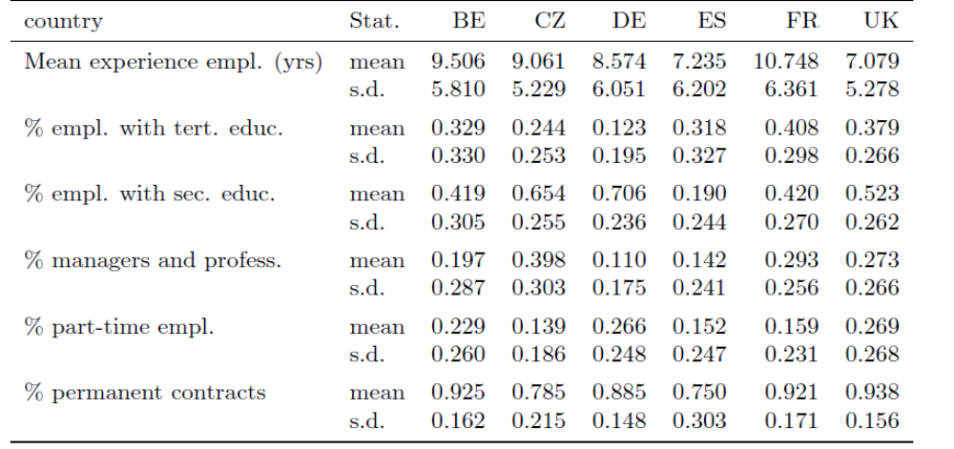
Table A4: Distribution of firms by modal age of employees by country
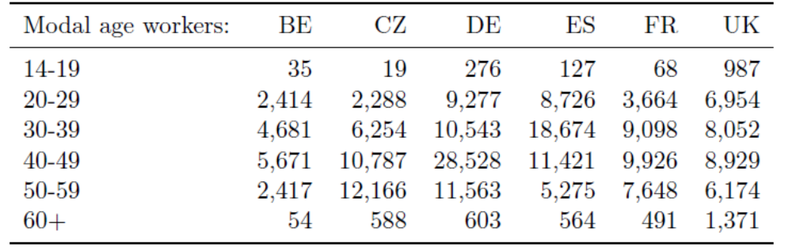

Appendix B: FLB propensity score estimation details

In order to address possible endogeneity driven by the potential self-selection of frms into a particular bargaining regime (FLB = 1), we essentially apply a two-step procedure based on propensity score estimates. We first estimate, separately by country, a preliminary first-step Probit:

${FLB}_{j}$= P ($α_{0}+α_{1}V_{J}$) (5)

where ${FLB}_{j}$is the dummy for the observed presence of firm-level bargaining in firm j, P is the Probit link function, and V a set of covariates that affect the choice to bargain at firm-level. In the second step, the predicted probabilities (propensity scores)[ $\hat{{FLB}_{j}}$= P (${\hat{α}}_{0}+{\hat{α}}_{1}V_{J}$)] obtained for each firm are included as an additional control variable, as shown in Equation 3 and Equation 4. The idea is that conditioning also upon the p-scores in addition to other controls solves selection due to unobserved factors, if FLB status is assigned as good as random based on observables. Thus, a simple OLS on the “p-score augmented" second step regressions will return correct estimates of the FLB dummy coefficient. Table A5 reports first-step Probit estimates, that we use to compute FLB p-scores for each firm. They show a satisfactory goodness of fit, in terms of relatively high values of the area under the ROC curve.
Notice that the predictors V are for the most part the same as the controls appearing in the set X in the main equations. However, to ease identification, we exclude average tenure of the workforce, as it is sensible to assume that tenure affects wages and wage inequalities, but it does not directly impact on the decision to adopt FLB. Also notice that, in place of the sector and region fixed-effects included in the controls X (likely subject to incidental parameter problems in Probit estimates), the set of covariates V includes the GDP per capita (at purchasing power parity, base year 2006) and the unemployment rate in the region where each firm is located, thus controlling for macroeconomic-and-regional dynamics that may play a direct influence on the decision to apply firm-level bargaining.

Table A5: Probit estimates of FLB propensity
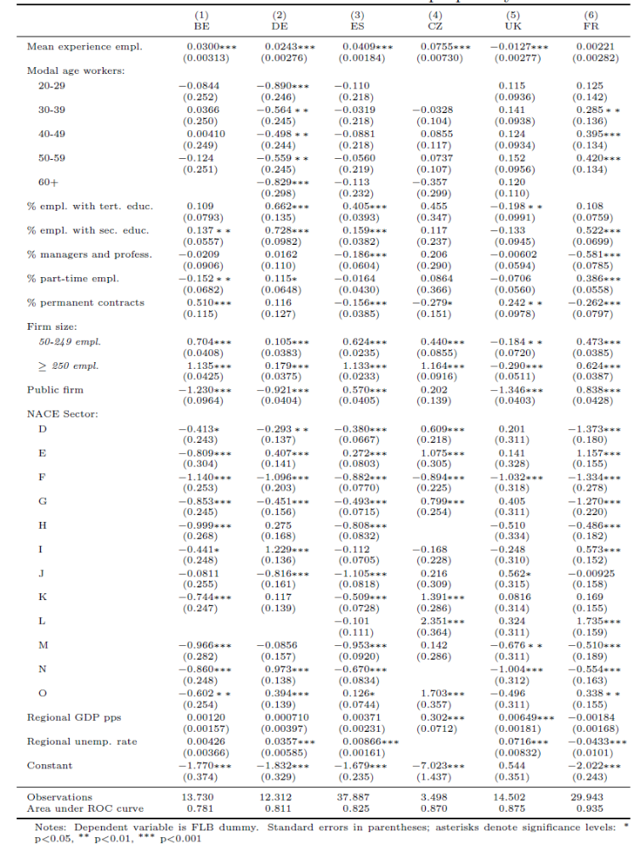

These additional variables are taken from EUROSTAT-Regional Statistics and measured at the level of NUTS-1 regions, since this is the precision of the information on firms' geographical location in SES.

